Assignment August 2016

Website Analysis

Gerard Crowley Modelmakers Ltd, Bray, Co. Wicklow.

[www.crowleymodelmakers.com](http://www.crowleymodelmakers.com)

1. Business Overview

Gerard Crowley Modelmakers Ltd is a company that specialises in the manufacture of one-off architectural scale models.

These types of models have been used for hundreds of years in the areas of architecture and engineering where they have been an essential way of helping communicate complicated designs and layouts that are not readily understood by ordinary people when viewing two dimensional drawings or blueprints.

More recently they have become the ‘go-to’ sales tool for any decent property development marketing suite, where they give the potential buyer an ultra-realistic miniature snapshot of a future life in the development, complete with tiny green trees, cars, children’s playgrounds and other amenities in a world of endless summer.

Marketing Suite Example:

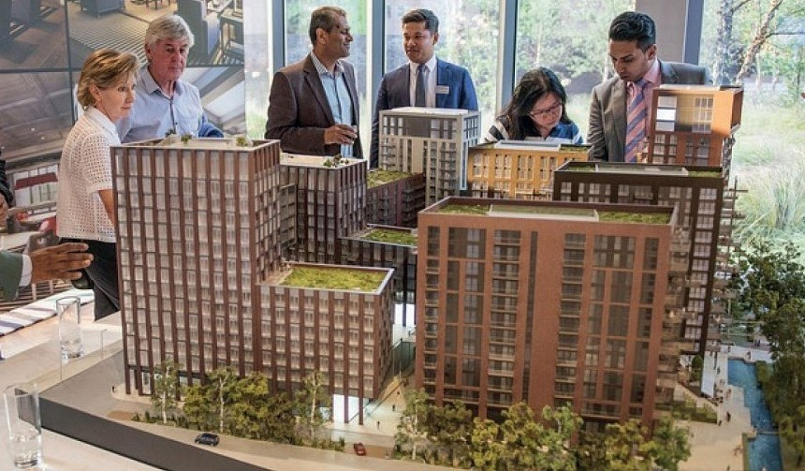

They are also used in Interpretive Centres around the country to show us glimpses of the past, to let us see the glory that once was of the pile of stones in a field now signposted as ‘Place of Historical Interest’.

Interpretive Centre Example: (Glendalough c.1100 AD)

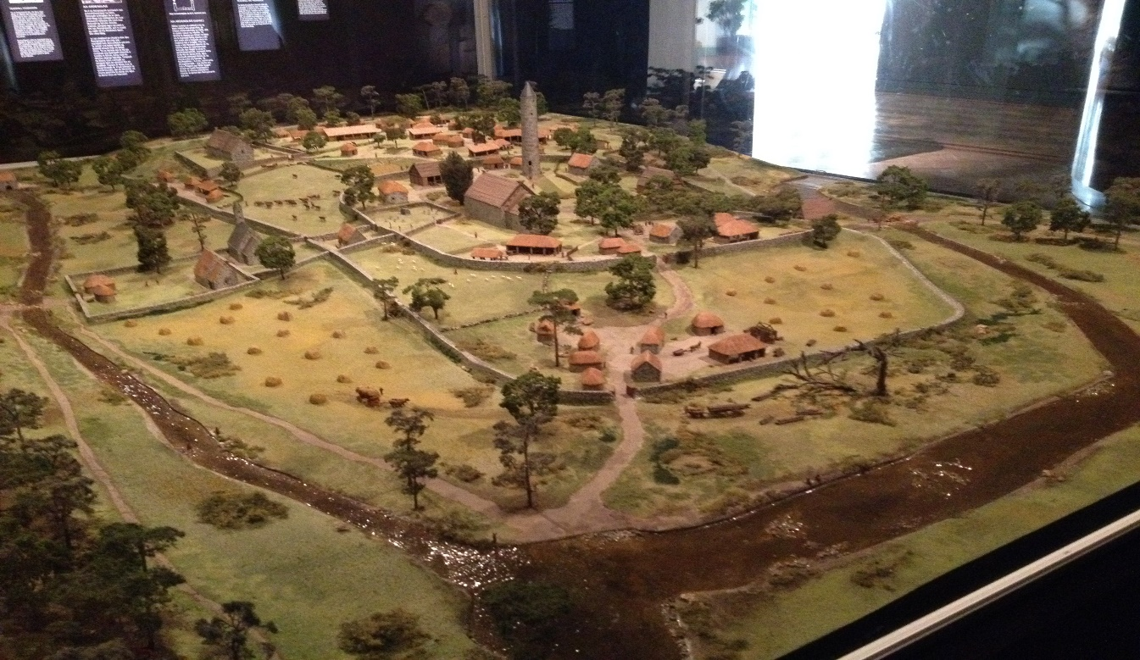

Typically, both these type of models, taking the sheer amount of skilled labour required into account, are expensive to produce and have always been paid for by either the wealthy developer looking to sell their scheme quickly or the Office of Public Works bringing a bit of historical kudos to a tourist attraction.

Almost a decade of little or no building development and major cutbacks in public expenditure have all but wiped out the career of the modelmaker in Ireland.

However, the very recent increase in housing demand and the government’s need to increase tourist revenue have both contributed to a resurgence in the requirement for scale models and in the short term at least, the future is looking good for the Irish modelmaker.

Having worked as a modelmaker myself, I picked this website to review, knowing that the financial restrictions over the last number of years meant there was little or no ability to keep the site updated and modern.

1. Review of Company Website

Appearance:

This is a very old website that no longer opens full page in a modern browser. It was designed when monitors/screens had far fewer pixels and before High Definition.

Home Page:

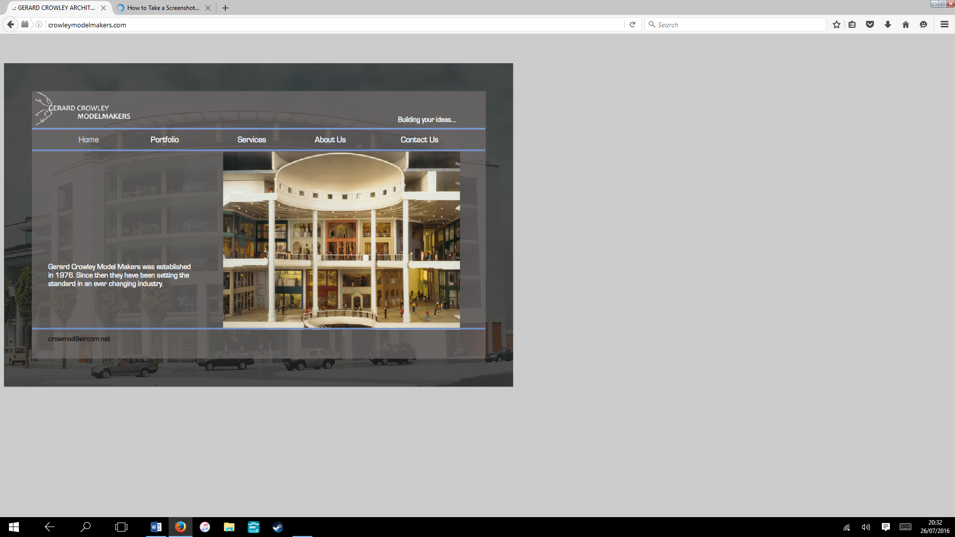

It does not open at all on a tablet or smartphone, giving a message that this type of plug-in is not supported!

Layout:

The ‘home’ page on the site is a dull grey colour with hard to read white lettering and four rotating low definition photographs of various models which were made many years ago and rotate too quickly to see them effectively.

The overall impression on visiting the site is that it is of poor outdated quality and has you wondering if the company is even still in existence.

Delving further into the site, we see a portfolio page of four categories which lead to further low resolution photographs, none of which have the opportunity to enlarge to full screen and allow us to see the finer detail of the models.

There is no use of either video or audio on the site.

Portfolio Page:

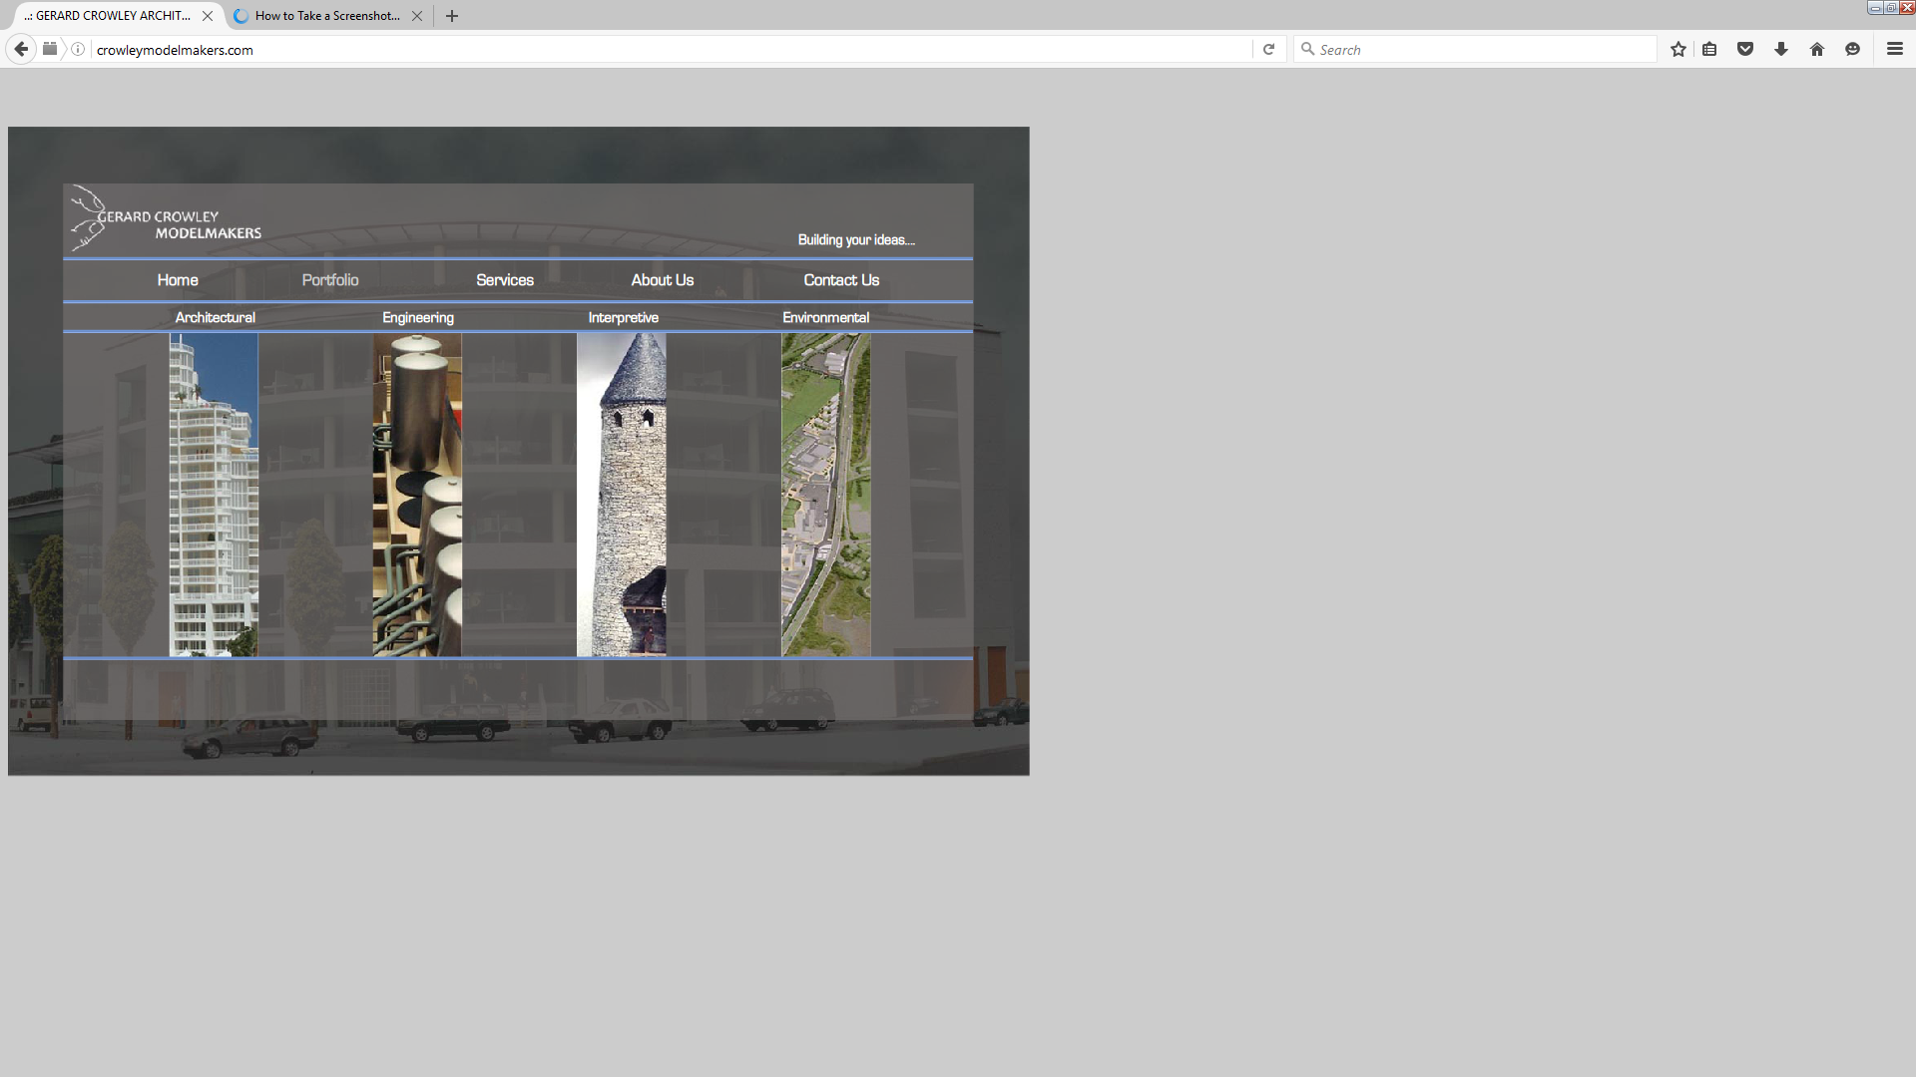

Photo Page Example 1:

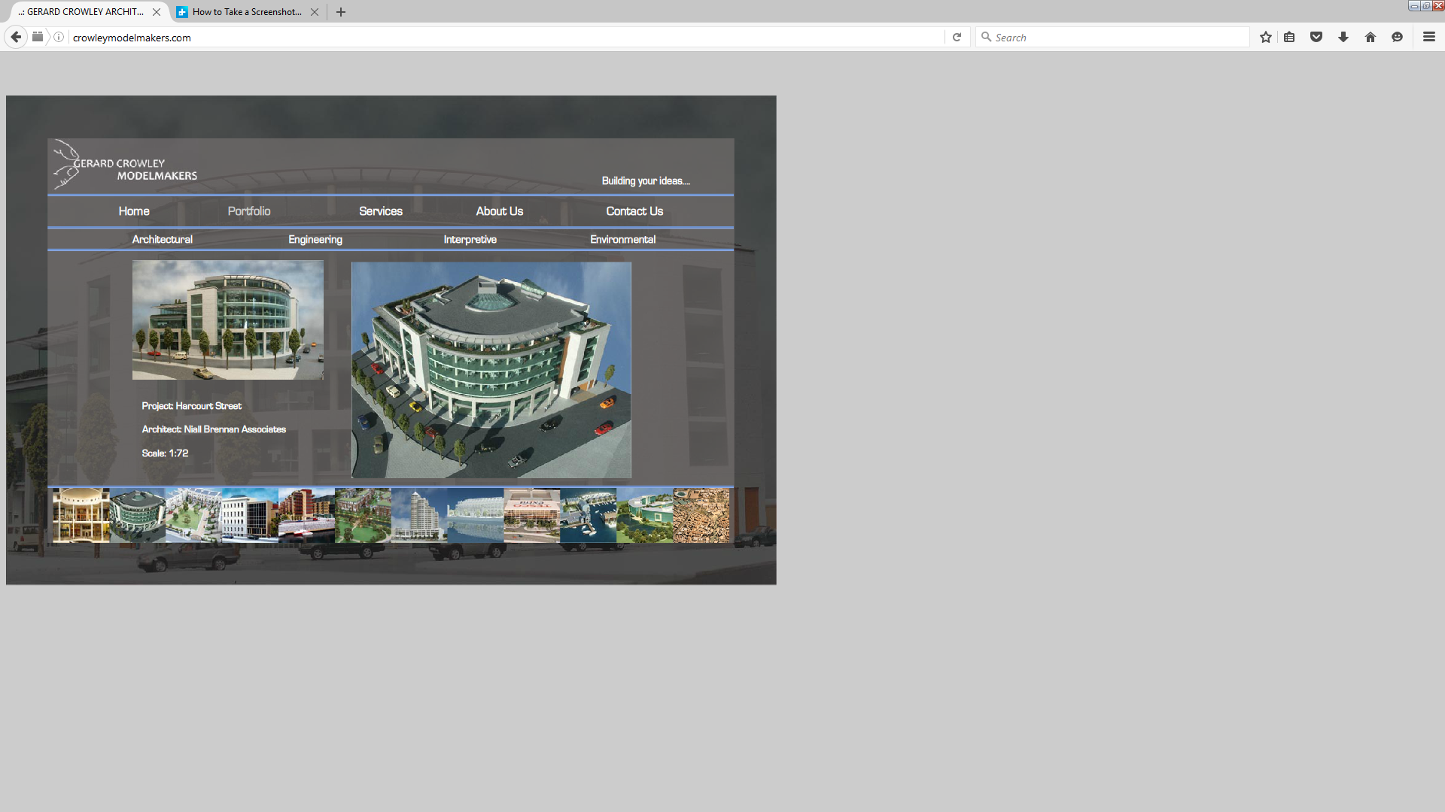

Photo Page Example 2:

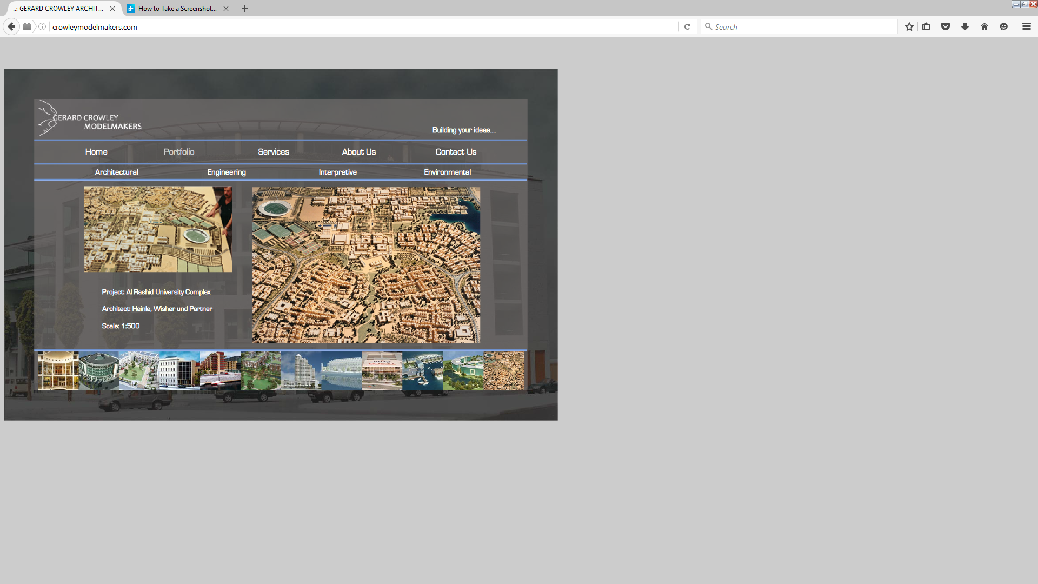

Services Page:

The ‘services’ page is superfluous as the model photos in the portfolio section should in themselves be enough to explain the service provided and create interest in the company.

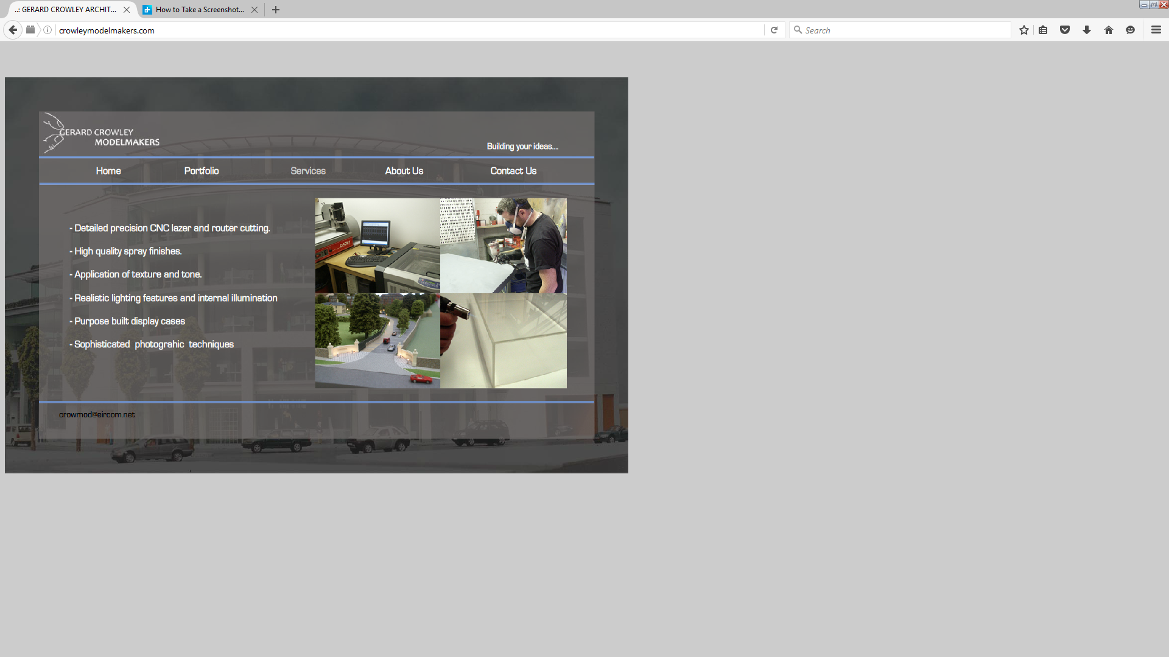

About Us Page:

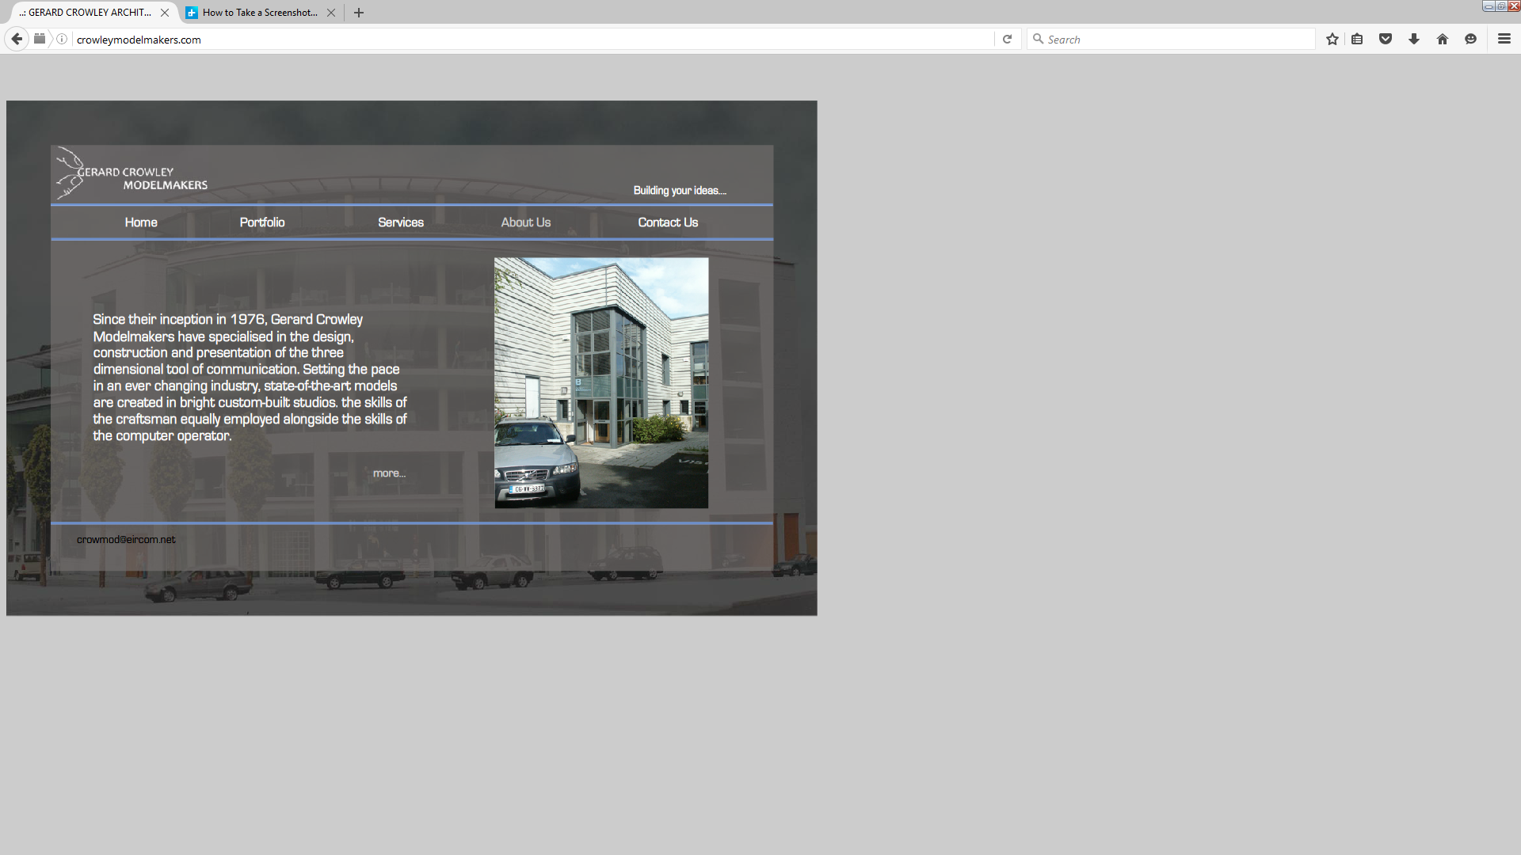

The About Us page actually consists of two pages, linked with a ‘more…’ icon. The first page looks initially like a used car advert and the second page uses overly complicated language to convey very little.

Contact Us Page:

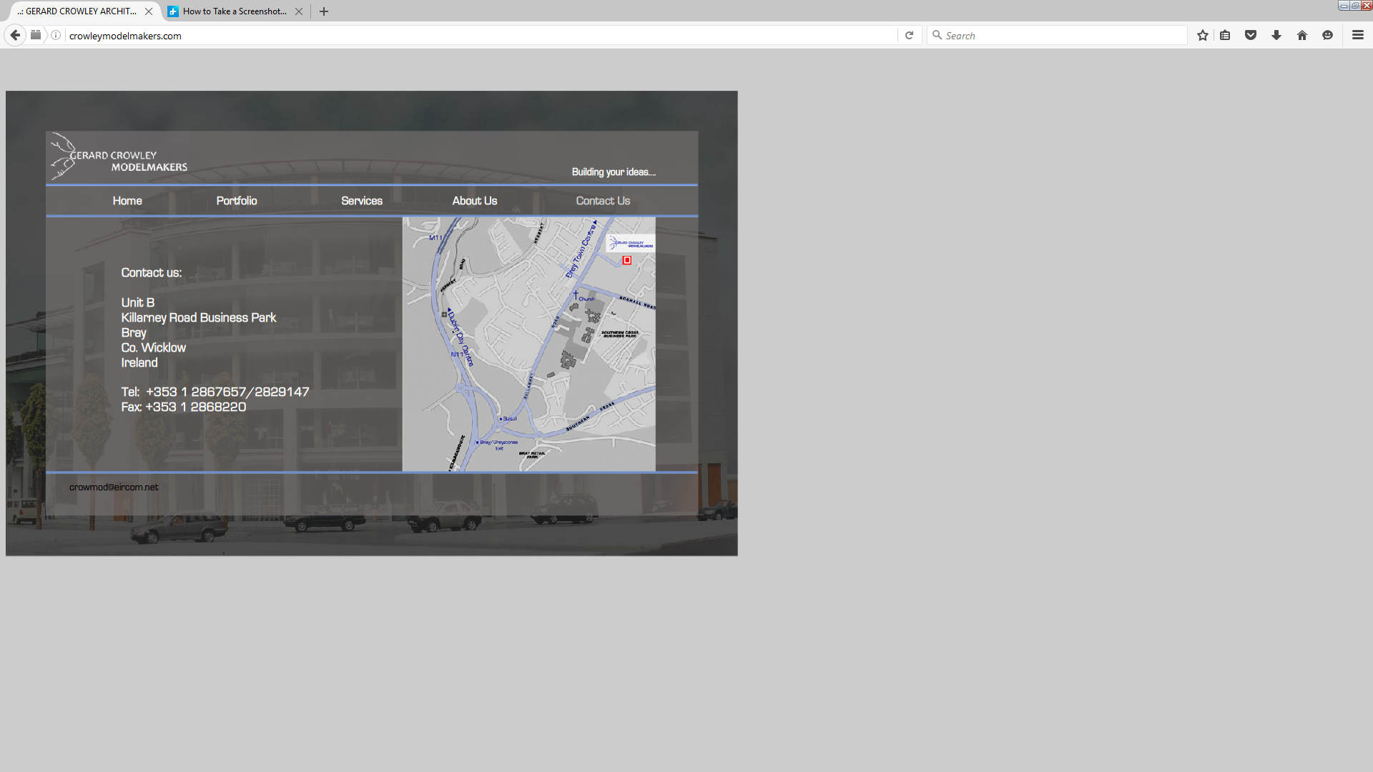

Again a very bland grey page with no link to automated email and a crude location map that is not connected through Google Maps to give driving instructions etc.

crowleymodelmakers.com - Overall Impression:

The overall impression of this site is of very low quality, which is not a good thing when advertising a business where quality is one of its most important attributes.

There is minimal navigation and it is not interactive in any way, which makes it appear even more outdated.

The fundamental requirement of an architectural model is that it should give the viewer the Initial Wow Factor and a ‘Warm Happy Fuzzy Feeling’ about the development and create a ‘want’ to be part of it.

In almost the same way, a company’s website should create an Initial Wow Factor and Warm Fuzzy Feeling and a ‘want’ to do business with that company. This website does neither.

1. Competitor Analysis:

Model Works Media, Dublin.

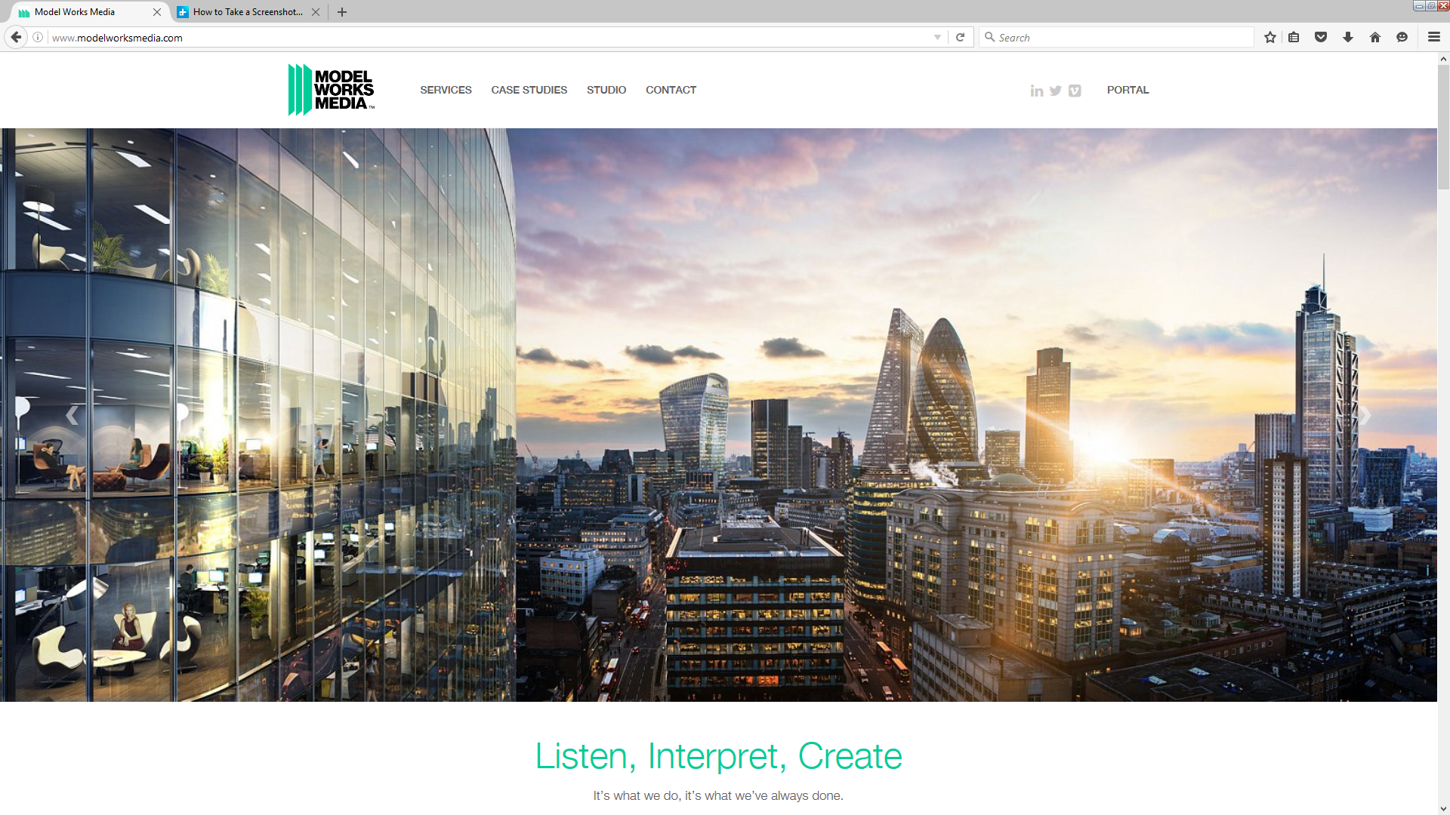

At the complete other end of the spectrum, Dublin’s Model Works Media have what is arguably one of the most visually stunning modelmaking websites in the world right now, having moved to the London market after the Irish property crash.

Model Works Media Homepage (with Boris Johnson):

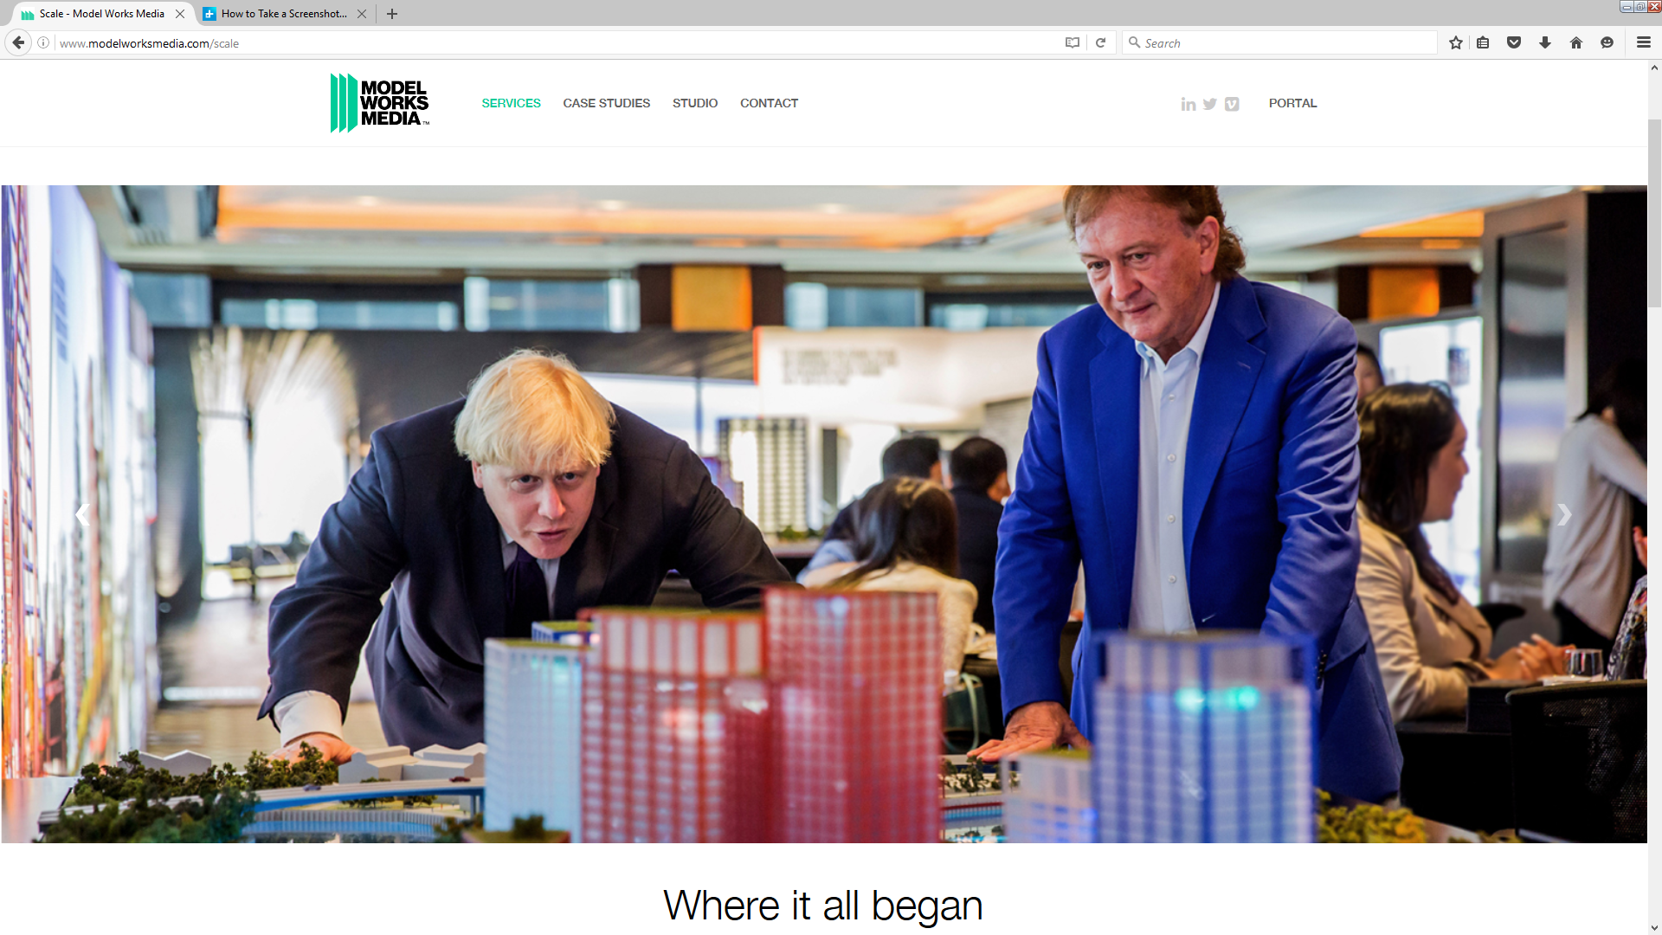

This is a modern ‘long scroll’ website layout, full of movement and special effects that draw the viewer in with layer upon layer of high quality images.

All of the images can be clicked in to make them ‘full screen’ in high definition, allowing all of the detail to be seen in clarity.

Full screen photo example (Battersea, London):

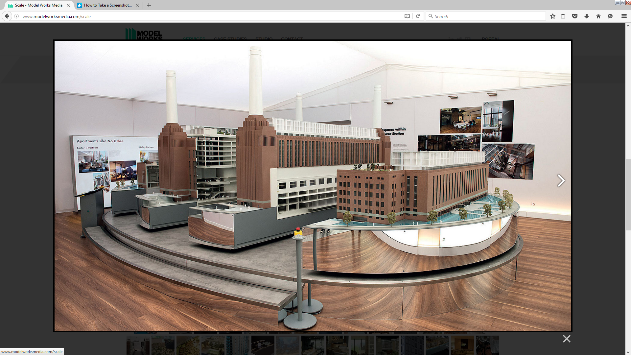

The site gives an impression of total professionalism and shows they have the ability to make presentations really special for the very high end property developer.

There are also sections in the site showing their abilities in the areas of Augmented Reality, CGI, Film and Virtual Real Time.

Model Works Media have had the foresight to mix the very latest in gaming and video technology with age old traditional hand skills to create an overall property presentation package that is surely second to none.

Film Page with an Embedded Video showing what can be done using a mix of all their services in property marketing:

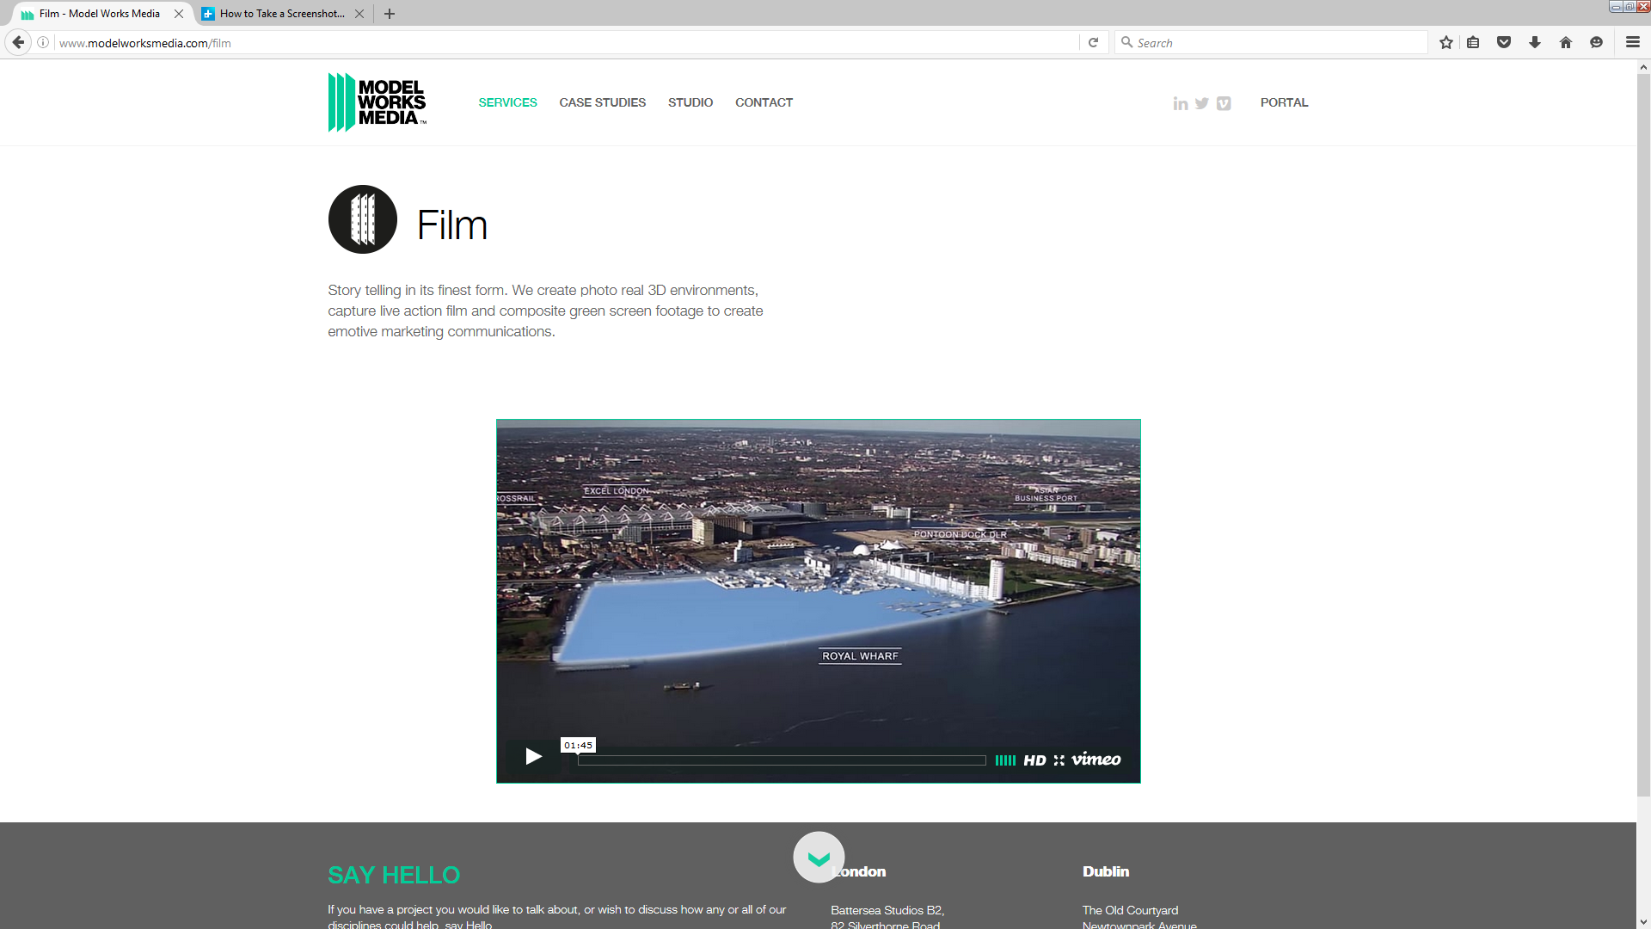

modelworksmedia.com – Overall Impression:

A superbly professional and impressive site that shows what can be done at the very limits of today’s technology.

However, it also says that if you don’t have an absolutely enormous marketing budget for your latest development, then don’t bother to come to us, you’re not in our league!

Gerard Crowley sees no competition from this site, nor is it intended to ever compete with this site. His company’s future is where it always has been, producing quality physical models at good value to the normal Irish property developer, not chasing the billionaires, but more than anything, he needs to let these developers know he’s still there.

1. Website Recommendations:

In order to let any potential customer know that the company is indeed still up and running, the website needs to be hugely updated and modernised.

The first priority is to rebuild the site in a modern high definition format that will allow more recent projects with fully detailed photos and close up’s of the models.

The site must have a minimum of reading material and a maximum of visual. Models are for looking at, not reading, and this exact message should be conveyed through the site. Let’s not forget the old adage,

A Picture Paints a Thousand Words.

Updating the font styles and colours and using .com as part of the name will immediately make it feel more up to date and ‘live’.

Using a white background will give it a clean modern look and will also allow the company name to stand out.

Example Home page

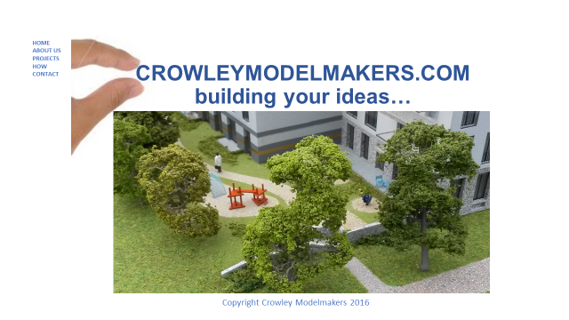

Studies have shown that the use of whites and greens generally in a website, generate trust in a viewer and as these models almost always have plenty of green spaces and trees, I think they should be made use of in the site photography.

Also the use of close up’s and severely cropped photographs will give them an air of intrigue and an interest to dig deeper into the site in a quest to see what else they can discover.

The About Us page should again have a minimum of text and an embedded video about the company and its services. If a Picture Paints a Thousand Words,

A Video Paints a Thousand Pictures.

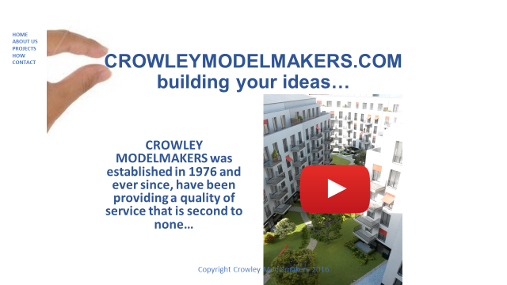

The Projects page will have no side text, using an ‘image slider’ we will let the photographic portfolio speak for itself.

Projects photo 1

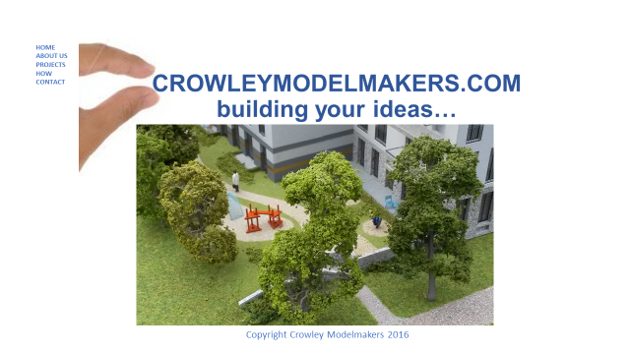

Projects photo 2

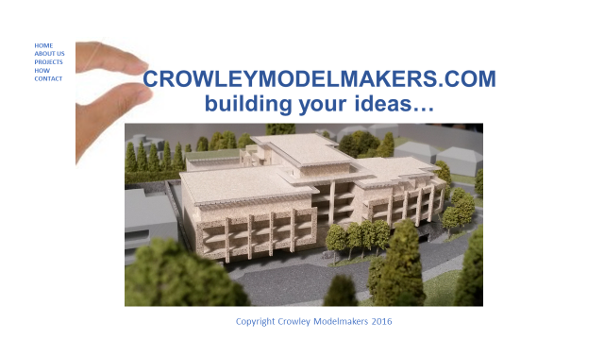

Projects photo 3

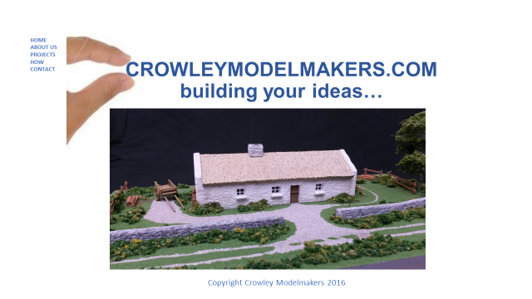

Projects photo 4

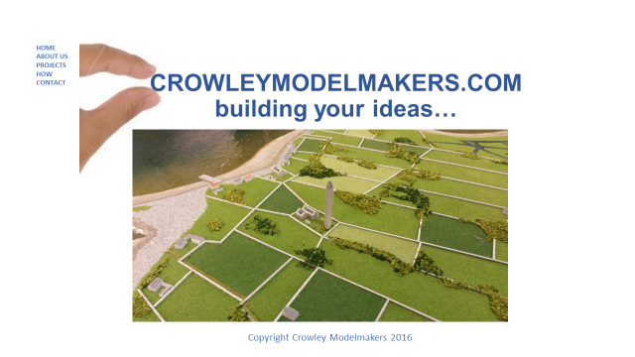

Building on the success of Discovery Channel’s ‘How it’s Made’ series, there will need to be a ‘how’ section where we explain a ‘little’ about how we work and the advantages therein, and an ‘image slider’ of three photos showing different construction stages of a model will give an understanding of the behind the scenes work that goes into them and help ‘build value’ in the service.

How photos

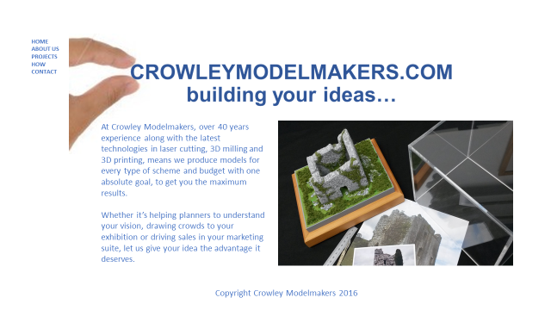

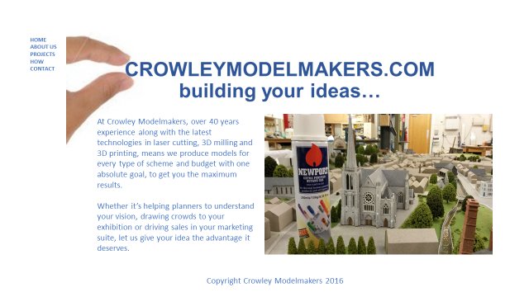

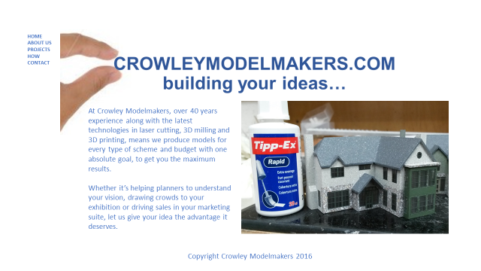

Finally, the Contact page will be updated using an interactive ‘google maps’ location box, using co-ordinates 53.190710, -6.121164 zoom 15 with a location kite and ability to use the co-ordinates in a modern SAT-NAV device. There will also be a ‘live’ email link to [info@crowleymodelmakers.com](mailto:info@crowleymodelmakers.com)

